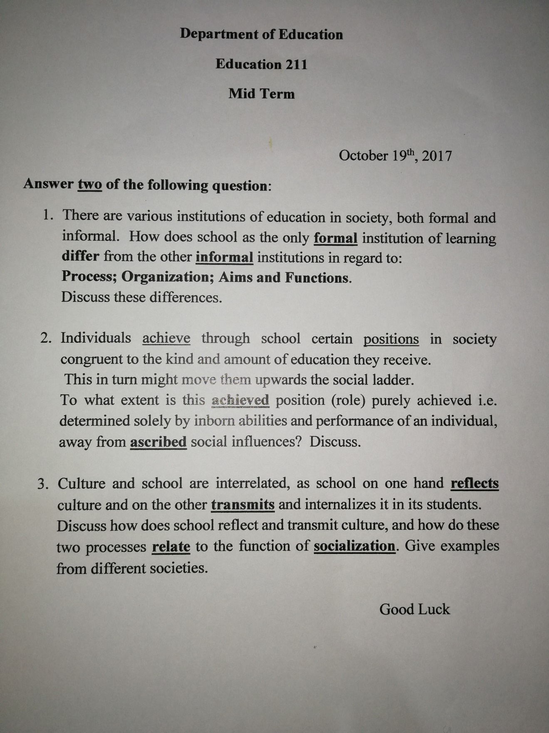
+NOTE: You can find a cleaner virgin of the exam on Previouses.com may be with an earlier date (It is a repeated exam :P )

First Question
Dr. Najla Bashour
Education 211
Note: the following answer was graded by the instructor and she gave it a high grade
_________________
When we refer to education is not the schooling at the schools or universities what we only mean. Education is much wider, it is every process that involves a giver and a receiver that result in a change in the person’s behavior. Accordingly it is classified into three types: formal, informal and non-formal. Indeed the types of education differs in many aspects: process, organization, aims and functions. So, how do formal and informal educations differ?
First of all the formal education is intentional education for a specific period and that is the case in schools, college, university…etc. According to the formal education kind and level the student reaches, he/she gets a certificate. That accreditation gives the student a position in the society. On the other hand the informal education is an unconscious education that is not limited to a specific time or even place for an example: family, peer groups, religious atmosphere…etc. Basically informal education is all about relations and interactions which mainly affects individual’s personality and might affect his knowledge. That forces students to acquire formal education because it is necessary for them to get jobs after they graduate which requires a certificates from registered institution, since no matter how rich her/his informal education is still the certificate is the passport to the labor market.
Furthermore, the school, the only formal institution of learning, is a whole organized set up. The school is organized in a specific way where there is (classes, boards, labs, materials, field….etc.) so that it all fits in the educational process. The school organizational pattern can affect the manner in which students and teachers interact. Meanwhile, the family organization is linked to quality of family life. The root difference between school and family is that at the school the relations are non-biological while at home it is biological. Accordingly, at school the teacher deals with the whole class with the same expectation from all the students. The teacher does not differentiate between the students according to their genders but according to each one achievements (academically and socially).In contrary, At home the parents deals with each children differently not expecting the same performance from them all. Also, there is a differentiation according to the gender at home, and the treatment of each child is relevant to his/her needs and not achievements.
What are schools for? What are its functions? What is the informal education for? And what are its functions as well?
Roughly speaking, the aim of education is to develop the individual abilities. In particular, the formal education aims to determine what kind of citizen we want. And According to John white: “the school promote the spiritual, moral, cultural mental, physical development of pupils and it prepares such pupils for the opportunities, experiences of adult life.” These aims are set by the highest political power and it is reflected by the curriculum (from literature and history to the regulations and rules of the school). On the other hand, the informal education and mainly the family strengthen and enrich individuals and family wellbeing (Thomas and Arcus 1992). In addition, the family develops the knowledge, values ,skills of the children to prepare the to the adult life creating be that a responsible citizen that can stand for him/herself and develop his/herself and the society.
About the functions of the school, at the level of the society the school enhance social cohesion and the development of the society. At the level of the individual there are mainly three functions for the school: selection and sorting of manpower, socialization, and social mobility. Selection which is the placement of the individual in society according the kid and amount of education they receive. Socialization which is preparing the individual to be a member of the society by internalization of commitments and capacities. Social mobility which is moving up the social ladder and improving one’s socioeconomic status. While the functions of the informal education (the family), are to transmits the cultural values to the children, and to provide social satisfaction by providing status, recognition, and further opportunity to relate to others.
Finally, both formal and informal education are indispensable. Each kind of education has its imprint on the individual and the society. But which one is more effective? And looking at the era that we are living in, the digital era, what will be the future of the school? What will be the future of education in general?

